| Defect ID | DF001 |
| --- | --- |
| Tittle | Overlapping |
| Test Cases ID | TCW- Dashboard homepage |
| Reported Date | 18/12/22 |
| Priority | Medium |
| Status | New |
| Descriptions | Elements saling tumpang tindih ketika mengklik layout sidebar |
| Expected Result | Element tidak saling bertindihan (Overlapping) |
| Actual Result | Element saling bertindihan |
| Report to | UI/UX |

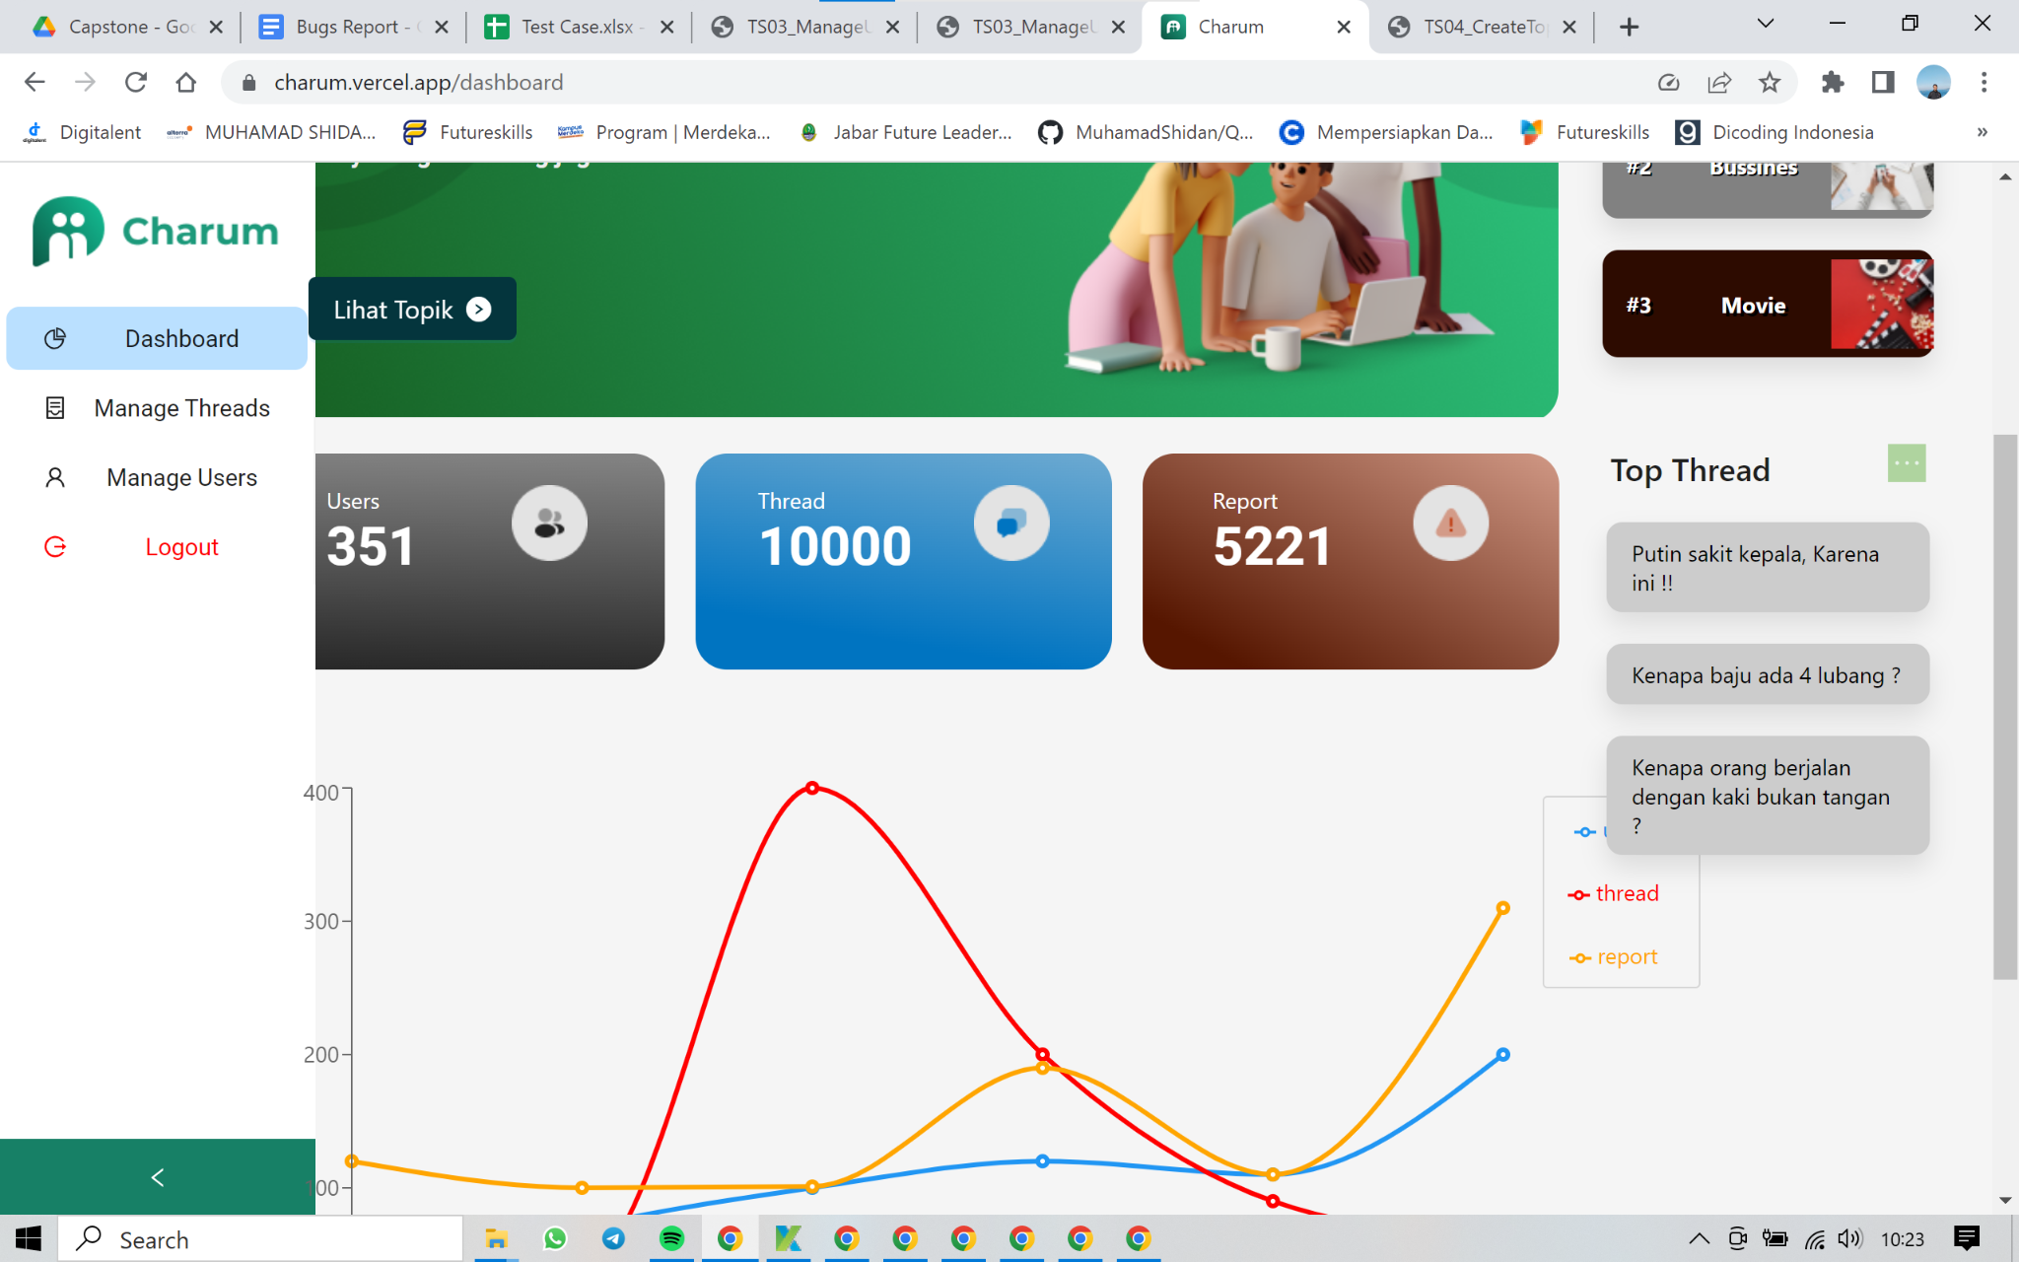

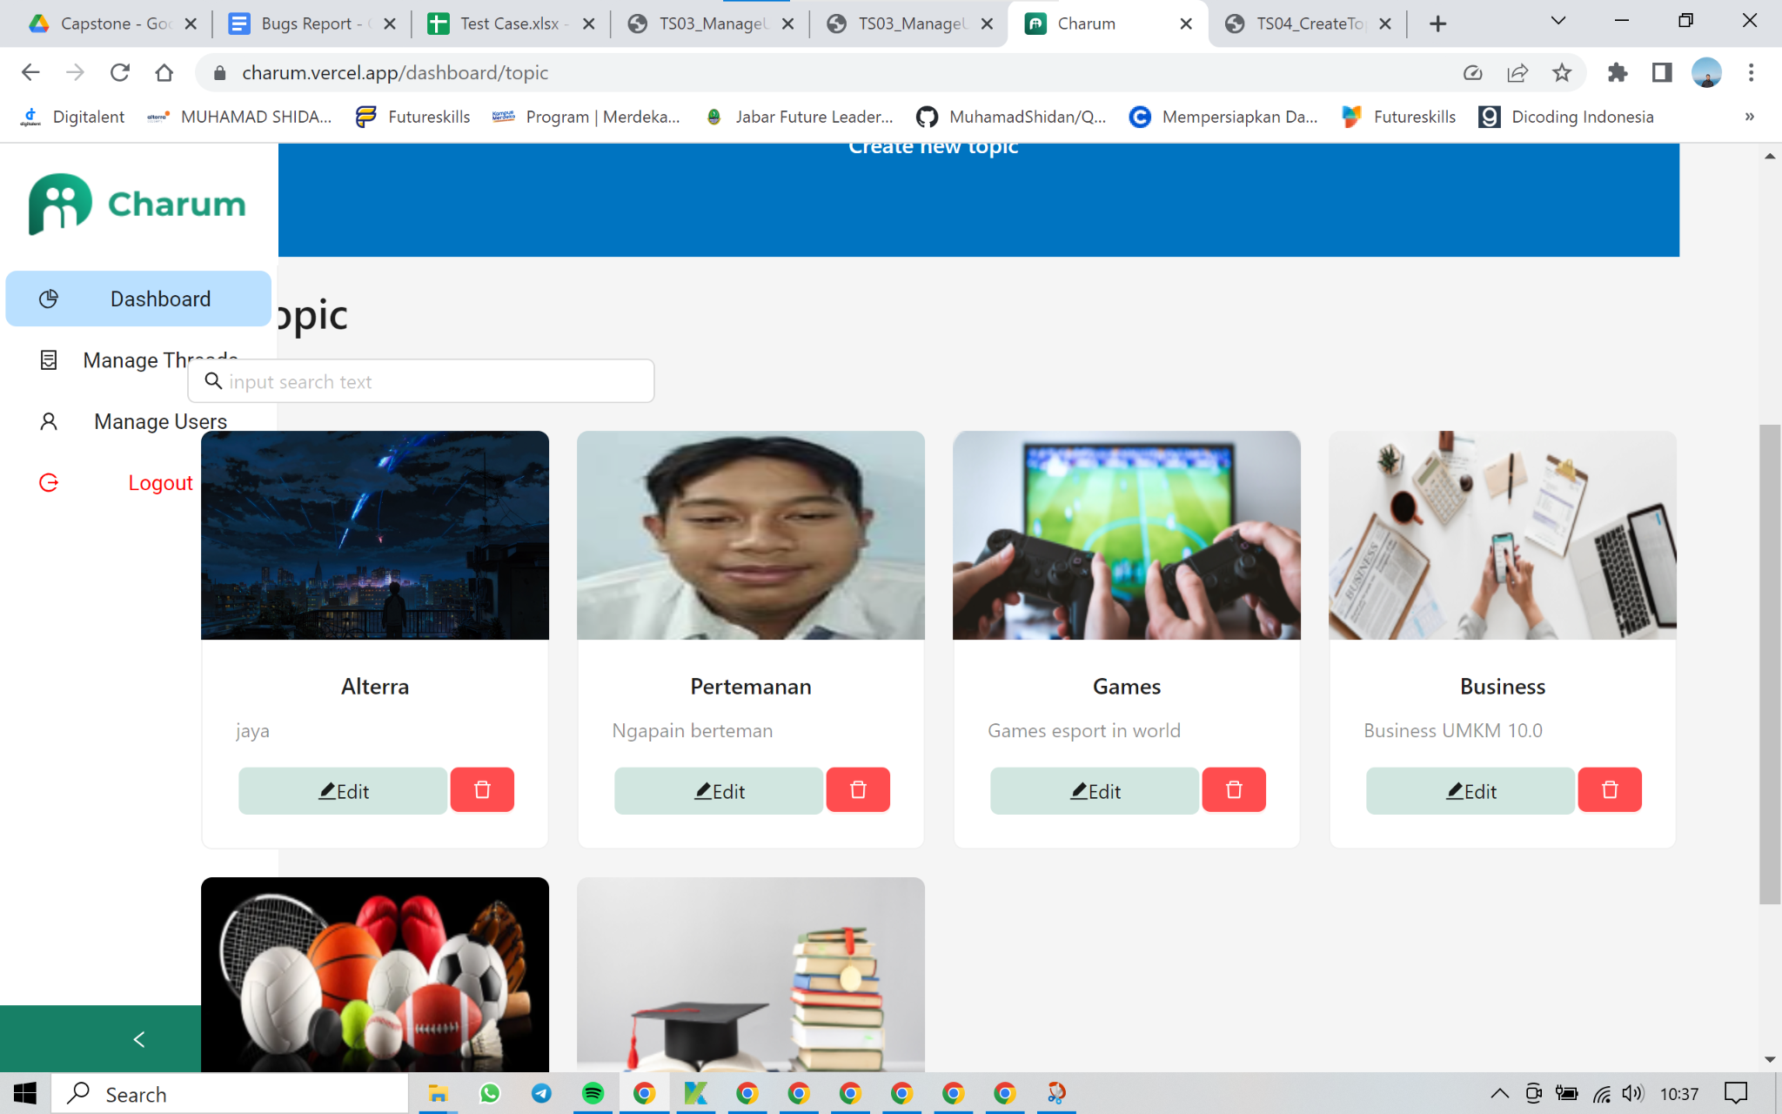

| Defect ID | DF002 |
| --- | --- |
| Tittle | Can’t add number or symbols to title topic |
| Test Cases ID | TCW- Dashboard topic |
| Reported Date | 18/12/22 |
| Priority | Medium |
| Status | New |
| Descriptions | User can’t add number or symbols when input title topic |
| Expected Result | User can add number or symbols |
| Actual Result | Title just fill with alphabeth |
| Report to | React |

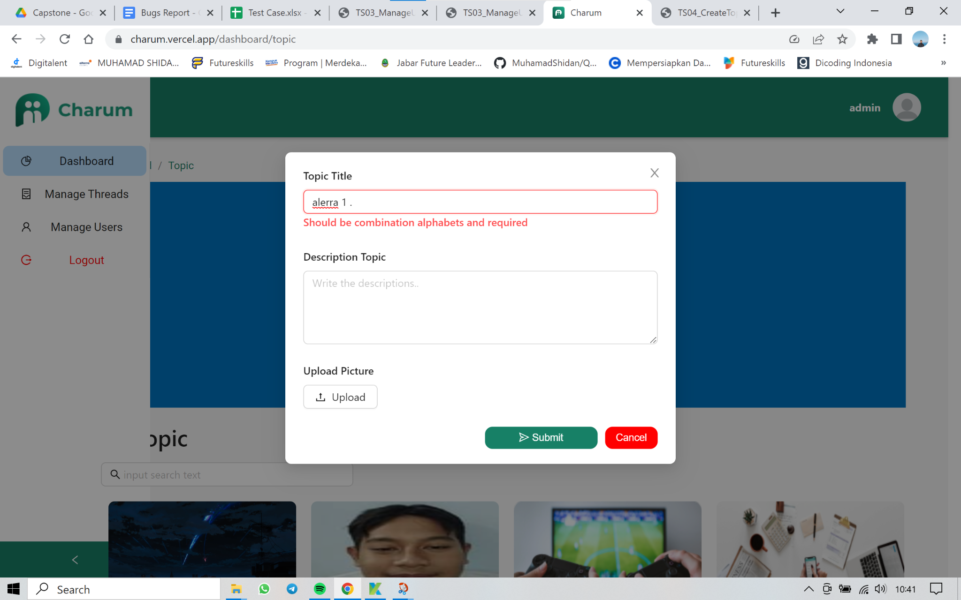

| Defect ID | DF003 |
| --- | --- |
| Tittle | User click manage topic thread |
| Test Cases ID | TCW- User manage topic thread |
| Reported Date | 18/12/22 |
| Priority | Medium |
| Status | New |
| Descriptions | User can’t acces manage topic thread |
| Expected Result | User can acces manage topic thread |
| Actual Result | Unauthorized |
| Report to | React |

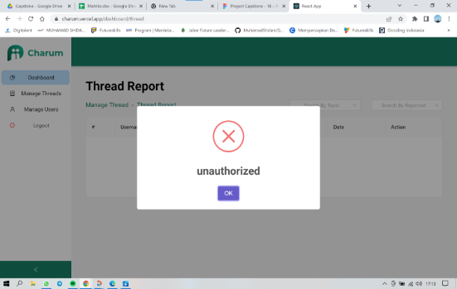

| Defect ID | DF004 |
| --- | --- |
| Tittle | User click manage user |
| Test Cases ID | TCW- User manage click manage user |
| Reported Date | 18/12/22 |
| Priority | Medium |
| Status | New |
| Descriptions | User can’t acces manage user |
| Expected Result | User can acces manage user |
| Actual Result | Object object |
| Report to | React |

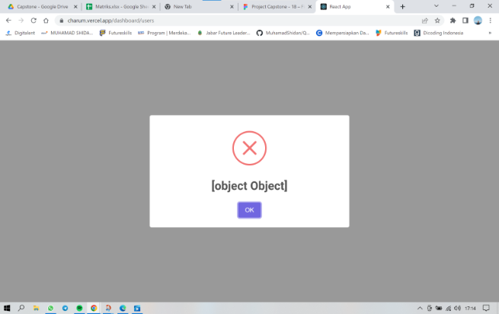

| Defect ID | DF005 |
| --- | --- |
| Tittle | Edit topic thread already post |
| Test Cases ID | TCW- edit topic thread |
| Reported Date | 18/12/22 |
| Priority | Medium |
| Status | New |
| Descriptions | After admin edit topic thread, when submit data disappears |
| Expected Result | Can update data |
| Actual Result | Data disappears |
| Report to | React |

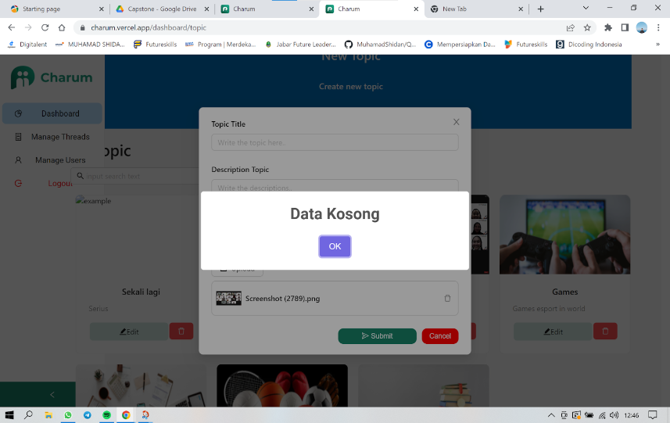

| Defect ID | DF006 |
| --- | --- |
| Tittle | Cant search data |
| Test Cases ID | TCW- search topic thread |
| Reported Date | 18/12/22 |
| Priority | Medium |
| Status | New |
| Descriptions | Can not search topic thread |
| Expected Result | Admin can search topic thread |
| Actual Result | Cannot search topic thread |
| Report to | React |

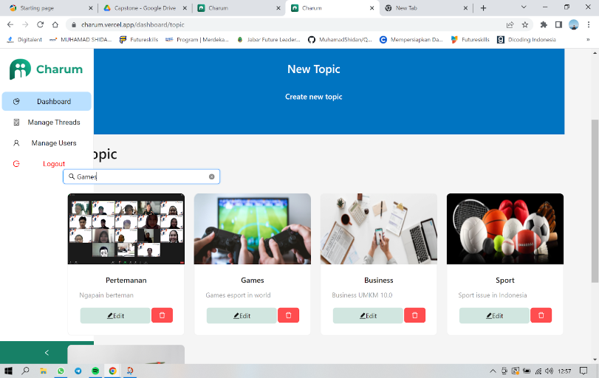

| Defect ID | DF007 |
| --- | --- |
| Tittle | Admin add image more than one |
| Test Cases ID | TCW- add image |
| Reported Date | 18/12/22 |
| Priority | Medium |
| Status | New |
| Descriptions | When admin add image more than one, image cannot display |
| Expected Result | Image can display when topic thread alredy post |
| Actual Result | Image can display |
| Report to | React |

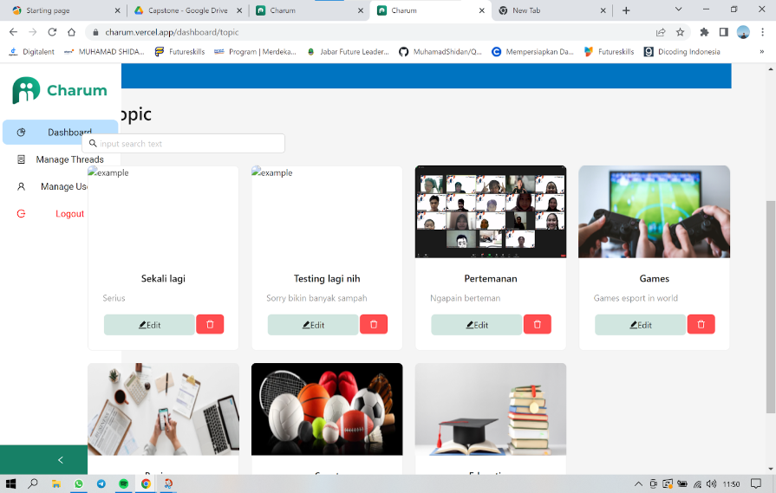

| Defect ID | DF008 |
| --- | --- |
| Tittle | User can register with invalid email |
| Test Cases ID | TCW- add image |
| Reported Date | 18/12/22 |
| Priority | Medium |
| Status | New |
| Descriptions | User can register with invalid email |
| Expected Result | User cant register with invalid email |
| Actual Result | User can register with invalid email |
| Report to | mobile |

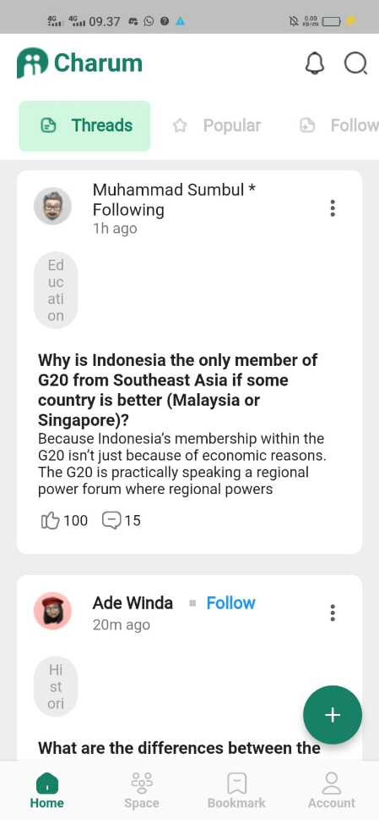

| Defect ID | DF008 |
| --- | --- |
| Tittle | User cant search tag |
| Test Cases ID | TCW- search |
| Reported Date | 18/12/22 |
| Priority | Medium |
| Status | New |
| Descriptions | User cant find the topic thread |
| Expected Result | User can search the topic thread |
| Actual Result | User cant search the topic thread |
| Report to | mobile |

